COVID In-building procedures 2021-2022
Highland Park Elementary- Version 2
COVID-19 Precautions and Mitigations
The health of Highland Park students and staff members is our top priority. The following guidelines are intended to provide protection for our employees, students, and community.
Administration, faculty, and staff has taken the challenge of planning for the reopening of school and has considered what teaching and learning will be like in the year ahead for teachers and students living under a new set of health and safety protocols. We have imagined the scenes inside of classrooms, on the playgrounds, in the lunchroom, at recess, at drop-off and pick-up, inside the library, and much more. The daily schedules and routines have been reimagined with new policies and protocols to maintain as safe and healthy a school environment as possible.
In order to meet guidelines regarding health and safety protocols in an effort to mitigate risk for our students and employees, we have made significant changes and investments to our classrooms and physical environments.
Shared understandings rooted in the development of our mitigation strategies include:
- Focus on the variables we can control;
- Use reliable, scientific sources to guide our understanding of the virus that causes COVID-19 and how to best effectively prevent our community’s exposure to it;
- Remain adaptable, knowing experts’ understanding of the virus will evolve;
- Seek ways to reduce risk of virus transmission, not eliminate it;
- Identify external and internal drivers that would lead us to modify our restrictions; and
- Ensure new policies are flexible and can be implemented and maintained.
Expectations for ALL of US:
1. Follow Federal, State, Local, and District Guidelines. (In This Together)
By working together, community members are expected to follow directives from national, state, local, and district authorities to maintain their own health and safety during this pandemic, both in and outside of school. These include Utah Department of Health and the CDC Guide on Protecting Yourself and Others.
2. Contact the Principal if a Community Member Tests Positive for COVID-19 or Has Pending COVID-19 Test Results.
If a student, employee, or any member of their household tests positive for COVID-19, or is awaiting test results, the Principal must be notified as soon as possible. This information will remain confidential, will be shared with the school nurse, and will allow the School to take necessary action to mitigate risks.
3. Stay at Home if SICK.
Please check their student’s health every day before sending them to school. If a student shows at least ONE of the following symptoms, please keep your student home.
- Fever or temperature of 100.4° F (38° C) or higher.
- Cough – If your child normally has a cough because of allergies or asthma, is this cough different than normal?
- Shortness of breath
- Muscle aches or pains not explained by exercise or activity
- Decrease in sense of smell or taste
- New runny nose
- Sore throat
- Nausea or vomiting
- Diarrhea
- Loss of taste
- Or any other COVID symptom per state guidelines
Any community member showing signs or symptoms of COVID-19 must not come to school. Parents/guardians must keep sick students’ home and away from others and report the illness to the school.
4. Keep Medical Information up to date with our office.
All medical information must be updated with family and emergency contacts and current medical information for a student to attend the first day of school. Contact the office at (Brenda.sherwood@slcschools.org) to update your information.
5. Masks Required.
Salt Lake City Mayor Erin Mendenhall issued an emergency order requiring masks in K-12 schools on 8/20/2021. All members of the community are always required to wear an appropriate mask while on campus. The order requires each student, parent, visitor and others to wear masks in kindergarten through grade 12 at a public, charter, or private school in Salt Lake City when in any indoor area of the premises, on school-provided transportation, attending an indoor school-sponsored activity, or outdoors on school premises when social distancing is not possible. The mandate contains some exceptions including while eating, drinking, and exercising. We encourage students to wear their masks from home to school, while at school and school to home (“door to door”) and when within 6 feet of others. There are exceptions for those students with authorized appropriate medical exemptions per state guidelines. Reusable face coverings need to be laundered daily. If a student forgets their facial covering, a disposable mask will be provided for them that school day. Each entry point will have a box of masks and sanitizer for easy access.
6. Instructional Schedule
- Monday – Thursday
  - First Bell- 8:40 AM, Tardy Bell- 8:45 AM
  - Dismissal- 3:15 PM (Morning Kindergarten- 11:25 AM)
- Friday
  - First Bell- 8:40 AM, Tardy Bell- 8:45 AM
  - Dismissal- 1:40 PM (Morning Kindergarten- 10:45 AM)

Highland Park’s COVID In-Building Procedures are detailed in the following sections.

Table of Contents
General guidelines
Adult Visitors
After school program
Backpacks and lockers
Breakfast
Classroom layout
Classroom sanitizing
Computer lab
Custodial cleaning and sanitizing
Dismissal from school
Entrance to the school
Essential visitors
Events/field Trips
Face coverings
Faculty lounge
Hallways
Hand washing/sanitizing
Indoor air quality
Laptops/student devices
Lunch
Night sanitizing
Physical distancing
Playground/recess
Plexiglass barriers
Policies when exposure occurs
Restrooms
Shared belongings
SLCSD COVID-19 Guidelines for Schools
Substitute chain of command
Teacher work rooms
Temperature checks
Water fountains/bottles

Appendix
COVID procedure posters
Health office visit
COVID-19 incident communication & reporting
Checklist of COVID-19 exposures

General guidelines
- Five keys: face coverings, distance, time, hands, disinfectant.
  - Face coverings- Masks are required while inside the building with the exception of active eating in the lunchroom. There are those who have authorized appropriate medical exemptions, as per state guidelines.
  - Distance- Six feet rule is the ideal in all situations, but not always feasible. Aim to get maximum distance whenever possible.
  - Time- Always consider this factor when making decisions. The longer the time frame, the tighter the adherence to CDC guidelines regarding exposure.
  - Hands- Wash them often or sanitize when washing is not possible. Always consider touch points and reduce them as much as reasonable.
  - Disinfectant- Our custodial staff is sanitizing the building often. At the classroom level, we are supporting this as well. The staff will sanitize all surfaces when necessary.
- Data is ever changing and evolving. Expect updates and changes to be made regularly.

Adult visitors
- In order to be admitted in the building, families must have been asked by a Highland Park employee to come to the building. We recommend that conferences are conducted via Zoom. If extremely necessary, a parent can schedule a meeting if they need to talk with an adult in the building.
- All adults who come into the building must remain in the office unless otherwise arranged.
- Volunteers are welcome to support one classroom. Volunteers will not be permitted to roam the building. Volunteers will sign in with the front office and report directly to their assigned classroom.
- Default response will be no visitors or volunteers unless pre-arranged with classroom teacher or school administration in advance.

After school program
- The After-school Program will practice the same mitigation outlined by HP.

Backpacks and lockers
- Backpacks and lunchboxes will be kept in student lockers or in the lunch wagon.
- Teachers will stagger students’ access to their lockers to ensure distancing.
- Items are to be taken home daily to allow for sanitizing.

Breakfast
- Served from 8:15 – 8:30 AM
- Breakfast will be served in the cafeteria.
- Students will enter the cafeteria doors from the courtyard.
- Students will sit at the designated numbers to ensure distancing.
- Students who finish their breakfast by 8:40 will exit the cafeteria through the playground doors and line up with their class. After 8:40, students will go directly to their classroom.

Classroom layout
- Aim for 6 feet spacing or as close as possible. Organization of classroom seating to maximize distancing.
- Keep classroom doors open while students are in the classroom to reduce this touch point.
- Classrooms should be using plexiglass barriers whenever possible and feasible.
- Students must have assigned seats for potential contact tracing. The same seating assignments must be kept throughout the day and must be kept at minimum for one week. Seating assignments should mirror their small groups. This means students in the same small group should be seated next to one another in the classroom (cohorting). Keep a record of all seating assignments for contact tracing purposes. This will allow to support small group work, ELD, and intervention.
- When having small groups or other activities that require movement, students still use assigned seating patterns. Number the seats as small tables and assign students the same number to use each day.

Classroom sanitizing
- Custodians will regularly wipe down high touch points including the door handle, sink area, and light switches.
- Teachers are provided with spray bottles of disinfectant and paper wipes for cleaning and disinfecting the remaining areas. Bottles are refilled as needed.
- Teachers will spray desks and students (when feasible) will wipe down their own desk. Desks will be distanced to the extent possible. Desk shields will be provided.
- High touch classroom supplies will be for individual use only. Materials will not be shared.
- Students will only be allowed to sit at their assigned desk. Movement will be minimized.

Custodial cleaning and sanitizing
- Products: Products and procedures are done in accordance to meet or exceed the CDC guidelines. Staff may not bring in their own cleaning sprays and disinfectant.
  - SLCSD Primary Cleaning Agent
    - The district’s primary cleaning agent is created by on-site generators - Salt Water Biocides which produces Hypochlorus acid. Hypochlorus Acid or HOCl provides a unique power to eradicate dangerous organisms while not causing harm to our cells. HOCl is one of the only agents that is both nontoxic to the delicate cells that can heal our wounds while being lethal to almost all known dangerous bacteria and viruses that threaten our health. Here is a link to an interesting article about the cleaner the district is using. https://www.dailymail.co.uk/news/article-8558121/Spray-costs-pennieskills-viruses-instantly-simple-solution-Covid-nightmare.html
- Methods: Our custodial staff in our facilities will be sanitizing routinely throughout the day using an EPA N list approved product. They will be wiping and sanitizing touch points and routinely checking and sanitizing the restrooms. This will be done on a schedule of at least 4 times a day and specific to the schools needs throughout the days of operation.
- Hand Sanitizer:
  - General: Custodians will maintain the hand sanitizer stations now throughout the buildings.
  - In the classrooms and other areas of instruction: School staff will be provided a hand sanitizer.
- End of day Cleaning: At the conclusion of the day, the custodial team will empty trash and do an end of day cleaning of the building then sanitize all areas used during the day with our approved equipment and sanitizer.
  - Deep clean and disinfect restrooms
  - Garbage, vacuum, dust and clean sinks in classrooms
  - Sweep, spot mop (scrub once a week) halls. Buff on a rotating schedule
  - Sanitize all touch points
  - Sanitize/disinfect desks, tables, chairs, counter tops etc. in all classrooms and offices
  - Final sanitation of the entire building using the Electrostatic Sprayer with the HOCI.

Dismissal from school
- The pack-up school bell time is at 3:00 pm.
- Teachers will begin dismissal prep and use locker rotations to gather student materials.
- Dismissal will start at the classroom closest to the exterior door. Then the next class dismisses, etc.
- Markings in the building indicate the direction of travel. Traffic flows on the right side of hallway.

Entrance to the school
- Before arrival
  - Encourage employee self-temperature and symptom checks
  - Families are encouraged to self-report temperature and symptoms. Students with symptoms must stay home.
- Upon arrival
  - Families will be encouraged not to send students early. Arrive just in time for the bell to begin school.
  - Students and families are not permitted to use the playgrounds before and after school.
  - Students report directly to their class line identified with the teacher’s assigned number. Lines are dispersed across school campus. Students will distance themselves using arm distance.
  - All teachers report to their class line to supervise at 8:35 am throughout the school year.
  - The front office will use the PA system to provide an announcement reminder to report to duty/supervision.
  - Students report directly to their desks and store materials in lockers using the locker rotations.
  - Markings in the building indicate the direction of travel. Traffic flows on the right side of the hallway.
- Tardies – At 8:45 a.m., all exterior doors will be locked. Tardy students will enter the front entrance. Between 8:45-9:15 a.m., they will report directly to class and complete a tardy slip. Ms. Tiffany Jensen will collect tardy slips from each classroom. After 9:15 am, tardy students report directly to the front office.
- Early Pick-Up Procedures- One parent or guardian will report directly to the front office and complete the sign-out process. The parent will be directed to wait for their student outside by the front entrance.

Essential visitors
- Essential personnel (defined as any person who is directly involved in the educational process of the school or has official school duties/business) will be allowed into the school building. Essential visitors, such as package and mail deliverers and facility repair people, will enter through our Main Entrance and report immediately to the Main Office prior to giving permission to move to another part of the campus. Signage near the entrance will indicate our health hygiene policy, including face coverings and hand sanitizing upon entering the building. All essential personnel visitors must:
  - Wear a face mask
  - Provide a photo ID
  - Sign into the school office
  - Wear a badge/ID lanyard for all employees to see
  - Meet/work only in spaces identified upon check-in
  - Sign out of the office

Events/field trips
- At this time, Highland Park is awaiting guidance regarding field trips.
- Grade levels will participate in school assemblies at different times to provide opportunity for distancing to the extent possible.

Face coverings
- Face masks are required at all times and in all places while on campus.
- There are a few students with medical mask exemptions. Written documentation has been provided for these students.
- It is beneficial if masks cover the full mouth and nose.
- If you notice a student has an old mask or is very dirty, then let the office know. The student will need a replacement.
- Students will be expected to provide their own masks, but we have many extra in the office to ensure all have access to one.
- When a student fails to bring a mask to school, they will be provided one.

Faculty lounge
- Only one person eating per table or distanced at the conference table. Please use the spray to wipe down your space when you are done eating. (Note you are welcome to eat in your room. Please wipe down your space when you are done in your room.)
- Do not share food items

Hallways
- Along with everything else, maximum reasonable distance will be pushed for when traveling through the hallways. The six-foot rule will be encouraged but may not be feasible in all situations. Students are expected to keep hands to themselves.
- At minimum, students should always have one arm length between them and the student in front of them regardless of size of line.
- Students and staff walk on the right side of the hallway.
- Arrows indicate these traffic patterns as marked in arrows on the floor.
- The front of the building has arrows to indicate the flow of traffic. Please follow the path, unless directed otherwise by office staff.
- Markings in the building indicate the direction of travel. These patterns follow similar patterns of in the past; traffic flows on the right side of hallway.

Hand washing/sanitizing
- It is necessary for teachers to ask students to wash hands frequently.
- Teachers should be mindful of tasks/transitions and build in time for handwashing.
- Students need to wash (20 seconds, the length of “Happy Birthday” sung twice) or sanitize their hands at the following times:
  - Upon arrival at school
  - At least every 2 hours
  - Anytime a student enters/exits a new space
  - Major Transitions (to and from lunch, etc.)
  - After being outside for physical activity
  - Before and after meals
  - After restroom use
  - After sneezing, coughing, or blowing nose
  - Prior to leaving school for home
- Teachers will determine how best to monitor students as to whether they are properly washing/sanitizing. Teachers will also need to develop a rotating schedule (i.e. during small group time) allowing students to wash and sanitize consistently throughout the day.
- Hand sanitizing stations will be set up throughout various locations in the building.

Indoor air quality
- Please keep your classroom door open while students are in your room. There may be exceptions based on need. This will support both circulation and reduce touch points of opening and closing doors. We have door stops available.
- Please do not open your windows. This interferes with the indoor air filtration process.
- The district did the following things to support air quality in the building
  - Increase the percentage of outdoor air introduced to the HVAC systems, and then subsequently conditioned for distribution throughout district facilities
  - Installed and maintain HEPA filters in all building HVAC systems. These are changed every month.
  - Installed and maintain air ionizers in all building HVAC systems
  - Prioritizing indoor air quality over operational efficiency in heating and cooling schedules
  - Exchange all building air overnight when environmental conditions permit
  - Accelerate maintenance schedules on HVAC equipment to ensure optimal function

Laptops/student devices
- HP is almost at 1:1 ratio for student laptops. Students will be assigned a laptop to use in the classroom.

Lunch
- Highland Park will use the gym and cafeteria to distance students during lunch. Three/four classes will be assigned a 40-minute period. Three/four classes will be eating and the other three/four classes will be on the playground. After 20 minutes, the classes will switch.
- Traffic will flow in one entry point and exit another entry point.
  - Traffic flow paths posted, marked on floors
  - Seats are distanced and assigned numbers
  - Shared spreadsheet with student assigned seat number, birthday, student state ID number
  - Hand sanitizer will be available in the lunchroom.

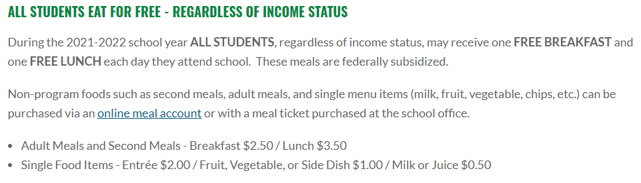

Nightly sanitizing
- Spray and wipe all counters, sinks, and touch points.
- Vacuuming and sweeping will be done every night. Please let Beau Bishop know if you are low prior to the evening cleaning.
- Classroom sanitization bottles filled if solution is low.

Physical distancing
- Ever pervasive goal of achieving six feet whenever possible.
- Organization of classroom seating to maximize distancing.
- Students must have assigned seats for potential contact tracing.
- Students will be expected to physically distance when walking in the hallway and in the classroom.
- Hallways will be clearly marked for distancing and directional travel.
- Outdoor spaces, when feasible, may be utilized. Maintain social distancing from all other classes.

Playground/recess
- Custodial staff will use the electro-static sprayer to spray the playground equipment.
- Playground line-up will be assigned for students to gather using arm-distance.
- Physical distancing is required in outdoor spaces.
- Students will wash or sanitize their hands before and after recess.
- Teacher discretion if they will provide playground equipment such as balls, jump ropes, hoops, etc. The equipment will be cleaned and disinfected by the teacher.
- Students are not permitted to bring their personal playground equipment from home.
- Running or walking the playground with social distance is always an option.

Plexiglass barriers
- We will have plexiglass barriers at a 1 to 1 ratio.
- Please use these whenever possible.
- These may be moved or removed only in special circumstances and returned as soon as is feasible.

Policies when exposure occurs
- Any policy for exposure goes through HR and the district nurses. Due to FERPA, very little information is free to share with others.
- We can work together to identify possible return dates, but how much is really shared needs to come through the nurse as she knows best what can be shared without violation of privacy.
- We can be clear about scenarios:
  - Isolation – Isolation applies to people who have COVID-19 symptoms, are awaiting the testing result, or have tested positive for COVID-19. This means to go home and stay home as directed.
  - If the student has been exposed at school in a mask to mask contact, does not have symptoms, they can get tested after 7 days and return immediately with a negative test result.
  - If a family member has tested positive and the students remain in the house, if the student does not have symptoms, they have to wait 10 days from the positive test plus any days until there are no symptoms from the adult (fever) and another 14 days for quarantine.
  - If the family has been exposed, they wait the 14 days in quarantine.
  - If at any point a student tests positive, they will stay home 10 days plus additional days until no symptoms (fever).
- Teachers are required to keep Canvas current with assignments. Students will have 5 days from the last date of absence to submit assignments for an excused absence.

Restrooms
- Up to 3 students may be in a community restroom at a time.
- Students will hang the classroom lanyard on the command hook outside of the bathroom while in the bathroom. This will signal other students to wait when the bathroom reaches max capacity.
- Red dots are outside the restroom to wait until a student can enter the restroom when large groups are going at a time.
- Only one student may be out at a time (from each class).
- Students will need to be allowed to go to the bathroom throughout the class and day; this may include inopportune times such as instruction to reduce mass usage of restrooms during traditionally high-traffic times.
- Masks ae required to stay on in the restroom.

Shared belongings
- Students may not share any belongings, including classroom supplies.
- Students may not share food of any kind.
- Students may bring store-bought, individually wrapped treats for birthdays or holidays. Teachers will distribute birthday treats in the lunchroom or at dismissal. Please do not send balloons, bouquets, or any other type of celebratory gestures to school.

SLCSD COVID-19 Guidelines for Schools

Preventing the spread of COVID-19 in school:
- Masks are required. There is clear scientific evidence that wearing a face mask reduces the spread of COVID-19.
- Social distance at least 6 feet whenever possible.
- Practice frequent hand hygiene.
- Disinfect and clean classrooms and other regularly used areas frequently.
- COVID testing in schools as recommended.

Isolation applies to people who have COVID-19 symptoms, are awaiting testing result, or have tested positive for COVID-19.
They must isolate (this means go home and stay home) until at least 10 days have passed since the first symptom appeared, symptoms have improved AND there has been no fever for at least 24 hours without the use of fever reducing medication.

Symptom Monitoring:
- Student temperatures will not be routinely taken upon entering school.
- Parents are encouraged to monitor for COVID-19. symptoms each morning before school.

Students who present during the school day with the following symptoms:
- Fever (100.4 or above) or chills
- Cough unrelated to asthma or different than normal
- Shortness of breath or difficulty breathing
- Muscle or body aches, not explained by exercise
- New loss of taste or smell
- Sore throat
- New congestion or runny nose
- Nausea or vomiting
- Diarrhea
Will be sent directly to the office, where they will be:
- Placed in a room designated for students with symptoms.
- Parents will be notified to come and pick-up their student, and follow-up with a healthcare provider.
Students who have symptoms at home or at school may return to school when:
- At least 10 days has passed since the first symptom appeared, symptoms have improved, and there has been no fever for at least 24 hours without the use of fever reducing medication OR
- Students have a note from a healthcare professional containing another diagnosis OR
- If there was no known exposure: students may return if they have a negative COVID-19 test, symptoms have improved, AND there has been no fever for at least 24 hours without the use of fever reducing medication.
- Students who have been fully vaccinated and are experiencing symptoms should be tested. They may return to school with a negative COVID-19 test, and 24 hours after symptoms resolve.
- All students returning to school after testing must present a copy of their testing results upon returning
- While awaiting test results, students will isolate at home.

If a student tests positive for COVID-19:
The parent will notify the school.
The school will notify the COVID technician, and they will:
- Communicate the student’s isolation information to parents, and the school POC.
- Determine quarantine dates for others in the family who attend SLCSD schools.
- Notify the Salt Lake County Health Department.
- Enter student information into the district COVID dashboard.

The student will stay home from school until:
- At least 10 days has passed since the first symptom appeared, symptoms have improved, and there has been no fever for at least 24 hours without the use of fever reducing medication.
If a student is asymptomatic, and tests positive for COVID-19, the student will stay home until 10 days has passed since the positive test.

Exposure:
- Exposure to COVID-19 occurs when a person is closer than 6 feet to a person who has tested positive for COVID-19 for 15 minutes or longer within a 24-hour period.

Guidelines for a school exposure
Individuals who are exposed to someone at school who tests positive for COVID-19 may continue to attend if:
- The exposed person:
- Is fully vaccinated (it has been at least 2 weeks since the final vaccine)
- Tested positive for COVID-19 in the last 90 days.
- Was wearing a N95 or KN95 mask (even if the person who tested positive was not wearing a mask).
- The person who tested positive and the person who was exposed were both wearing masks.

Anyone who does not meet the criteria above, and masks were not worn, must follow the current guidelines for quarantine and exposure:
- Parents of students who were exposed at school can choose one of the following options for their student:
- Continue to attend school wearing a mask for 10 days. After the 10th day, if there have been no symptoms the students may attend without a mask.
- Continue to attend school wearing a mask. On the 7th day, the student may get tested. If the test is negative, and there have been no symptoms, the student may attend without a mask.
Individuals who choose the above options should continue to monitor for symptoms until 14 days after the exposure and quarantine and consult a healthcare provider if symptoms occur.

Parents may instead choose one of the standard quarantine options for their student:
- Ten-day quarantine without testing. If the person who was exposed to COVID-19 lives with the person who tested positive, the person must quarantine for ten days, beginning from the last date there was contact with the positive person. After the tenth day if there are no symptoms, they may leave quarantine. They should continue to monitor for symptoms until 14 days after the exposure have passed, and resume quarantine and consult a healthcare provider if symptoms occur.
- Seven-day quarantine with COVID Testing: If the person exposed does not live with the person who tested positive for COVID-19, and they have had no symptoms, they may receive a COVID-19 test 7 days after exposure and return to school if it is negative. They should continue to monitor for symptoms until 14 days after the exposure have passed, and resume quarantine and consult a healthcare provider if symptoms occur.
If any symptoms occur, they will quarantine and consult a healthcare provider or the health department for testing information.

Test to Stay
Schools are required to Test to Stay when:
- Schools with 1,500 or more students have 2% of their students test positive for COVID-19.
- Schools with fewer than 1,500 students have 30 students test positive for COVID-19.
Parental permission must be obtained for testing.
- All students must test to stay in school when thresholds are met, even if they have tested positive within 90 days, or have been fully vaccinated. Students who parents choose to not participate in testing will switch to virtual learning for 10 days.
- Parents may provide a test result for their student if the test was done on or after the school testing date and the test was a PCR or antigen test.
- Students who do not test or test positive will follow isolation guidelines described above

Procedure for tracking cases:
- Health Department will track positive cases within a moving 14-day period for the Test to Stay threshold
- Once the threshold is met the school representative and health department will set a date for school testing
- Health department will provide a letter to the school/superintendent for meeting the 2% threshold
- Health department will provide a letter for schools to send to parents explaining test to stay and what is expected of them
- Health department will provide testing/results to the school

Students returning to school after testing must present a copy of their testing results upon returning. All tests must be a PCR or antigen test.

COVID Techs will:
- Work with, school POCs and parents to collect information to submit to the Health Department.
- Assist POCs with contact tracing.
- Communicate isolation/quarantine information to parents and school POCs.
- Enter and track isolation and quarantine cases into the district dashboard.

District Nurses will:
- Provide COVID-19 training and answer questions for SLCSD employees.
- Assist COVID techs as needed.

Key Things to Know About COVID-19 Vaccines (cdc.gov)
American Academy of Pediatrics Updates Recommendations for Opening Schools in Fall 2021 (aap.org)
COVID-19 and Schools - Salt Lake City School District (slcschools.org)
Updated 8/16/2021

Substitute chain of command
- SLCSD has a substitute notification system that will be used in the event of a teacher absence. An in-house substitute rotation list will be established to provide substitute coverage in the event that a SLCSD substitute is not available. Substitutes will be given instruction on COVID school safety procedures.
- We will continue to work on determining a site-based list of who becomes the sub as it is difficult to find subs at this time.

Teacher work rooms
- Teacher work room can only have two people in it at a time.
- If you use a general piece of equipment, spray a paper towel and wipe down your area before leaving.
- If possible, bring your own pen, pencil, pair of scissors, etc. to use.

Temperature checks
- We are not doing temperature checks.
- We will encourage families to conduct regular morning checks of their students, so that these kids never enter the building.
- We will check student temperatures if they are sent to the office with other symptoms.

Water fountains/bottles
- Students will be encouraged to bring a clean, filled water bottle daily.
- Students are highly encouraged to use the water bottle filling stations.
- Bottles should be labeled with names and kept in the room.

Appendix

COVID procedure posters

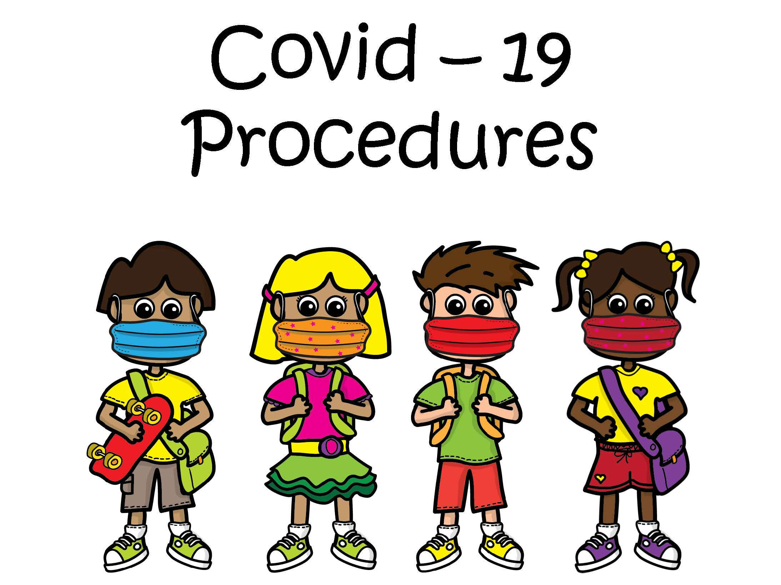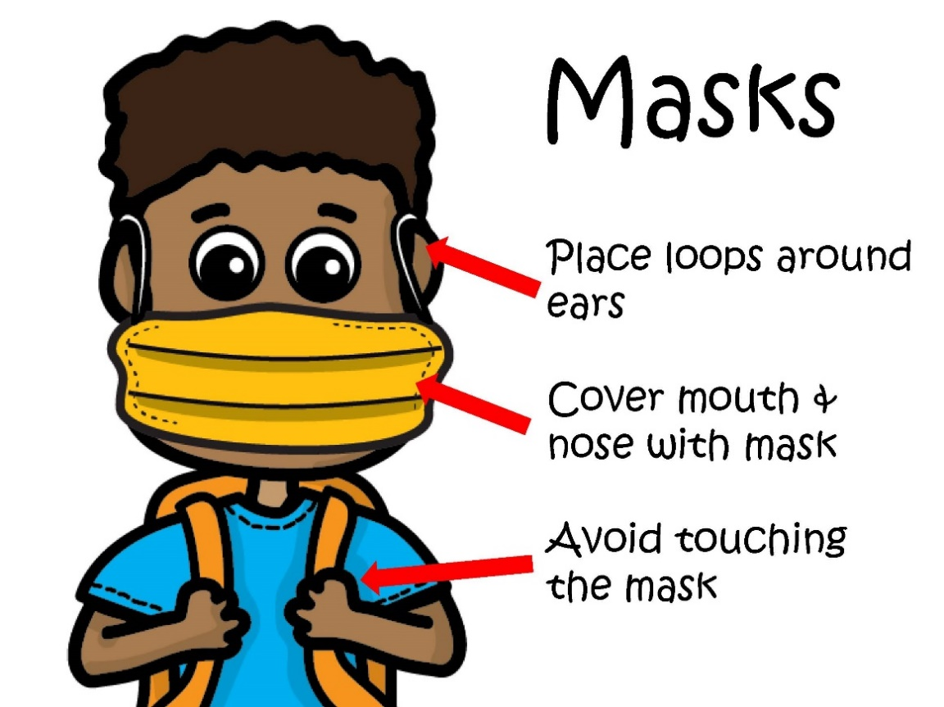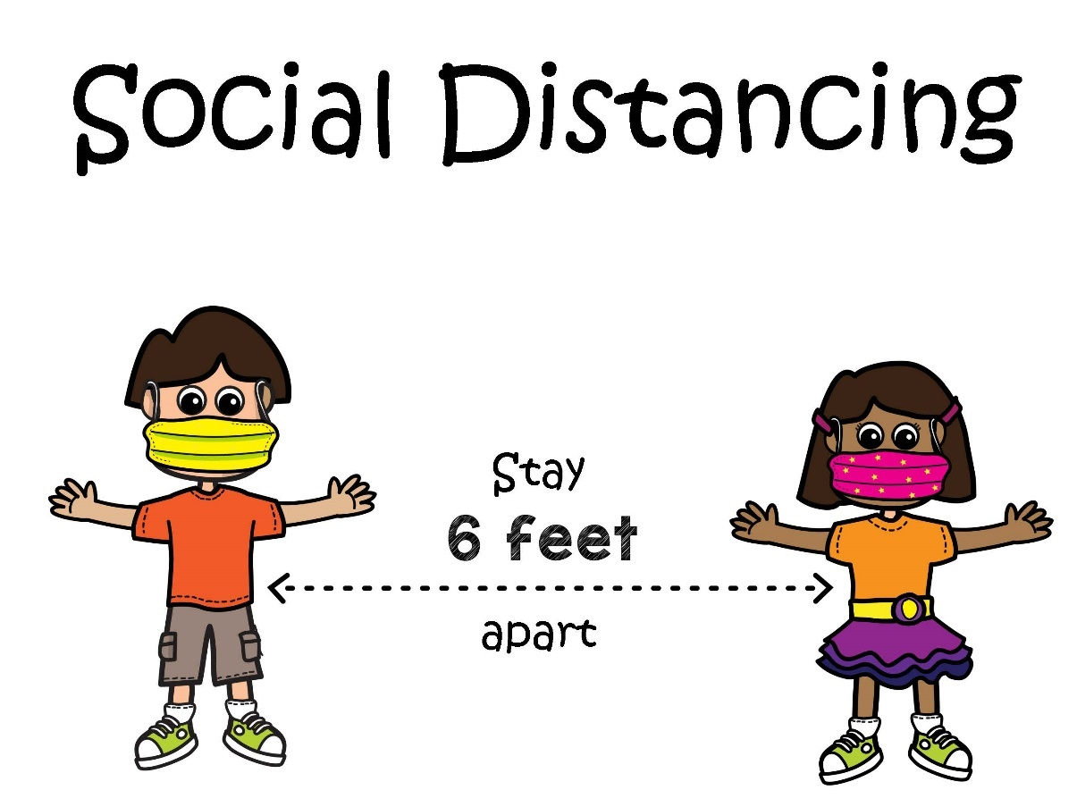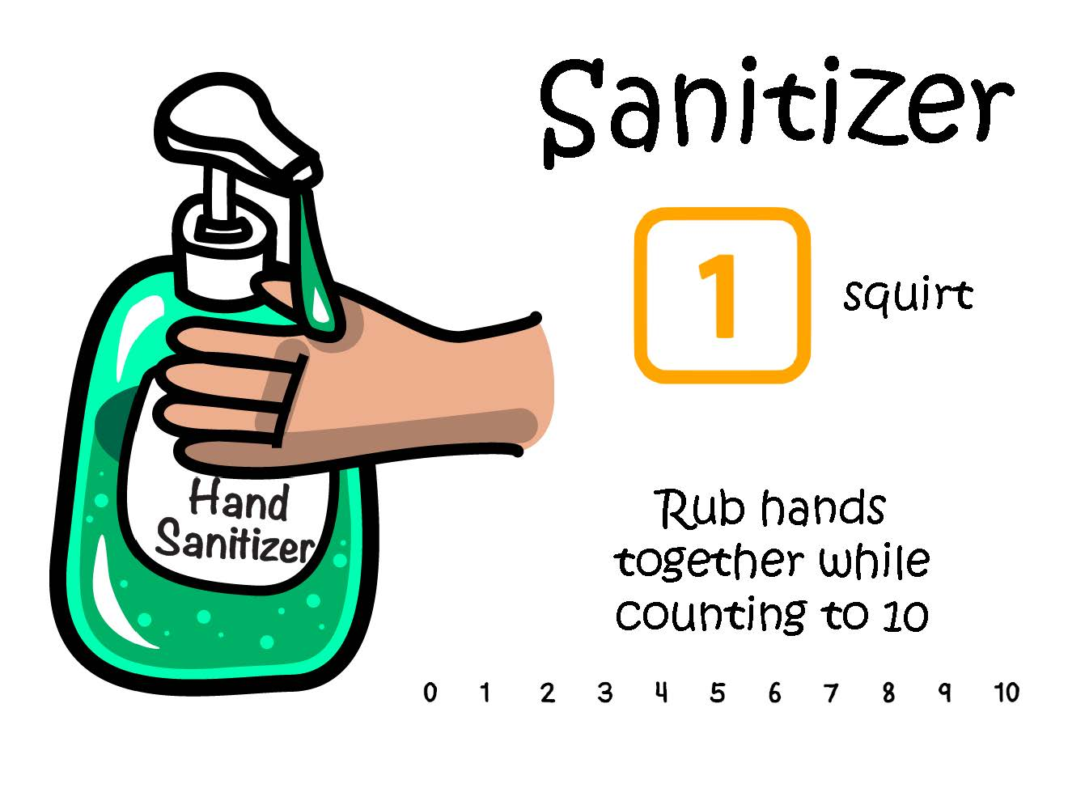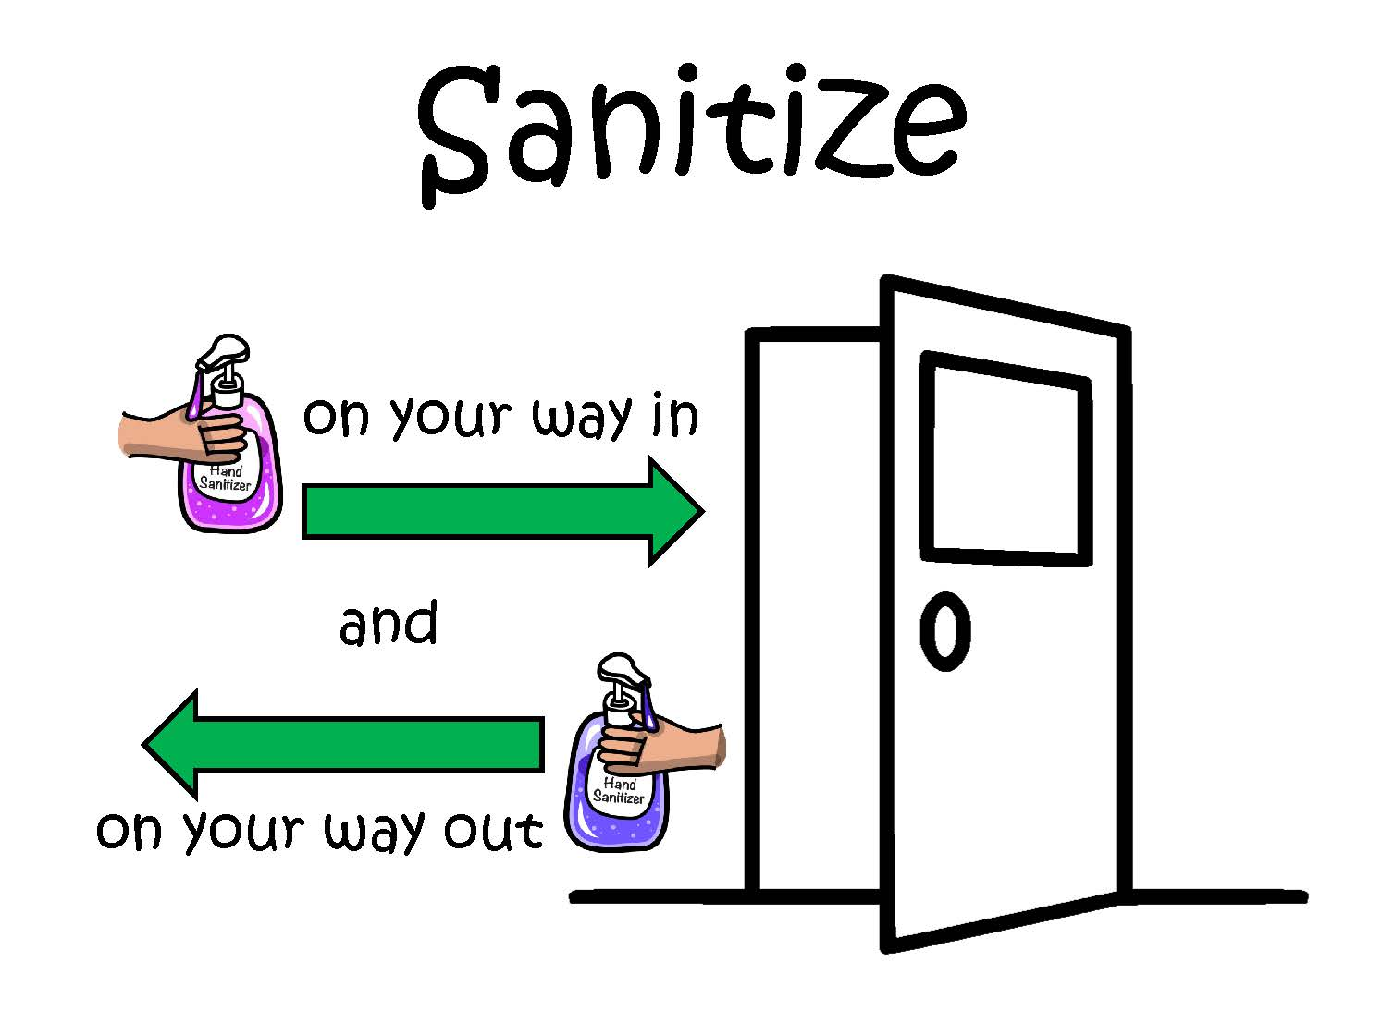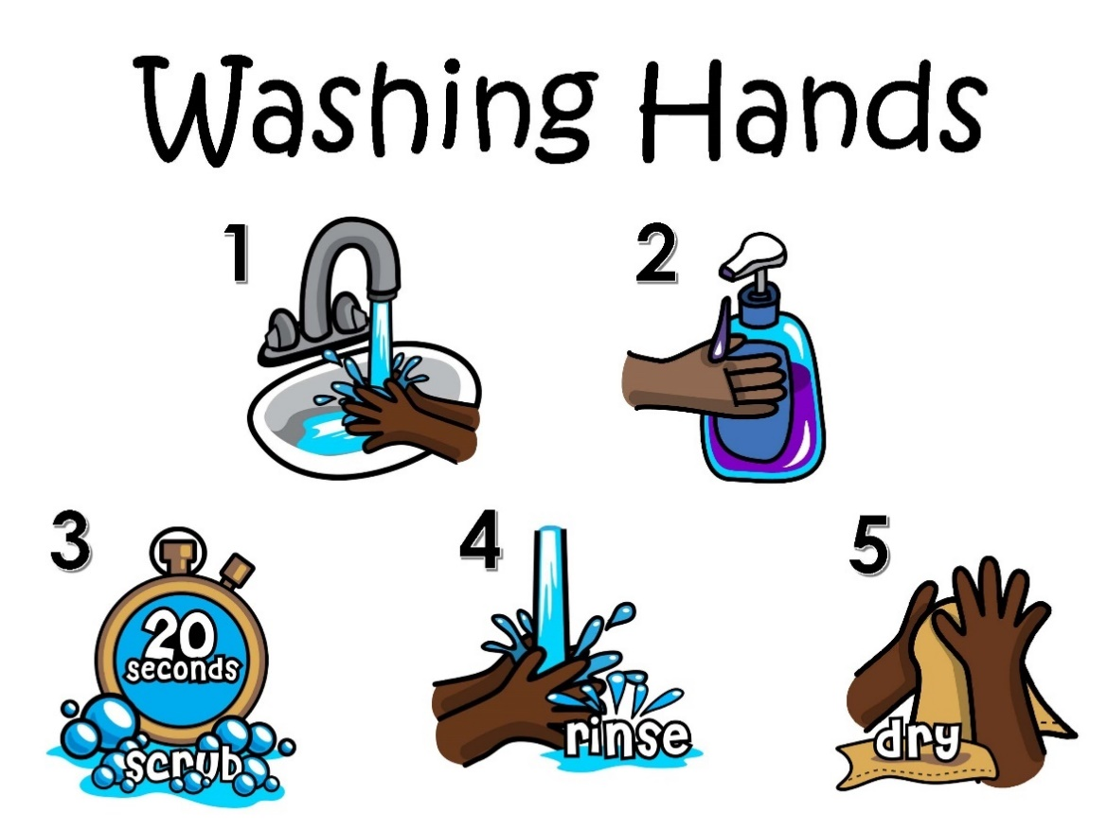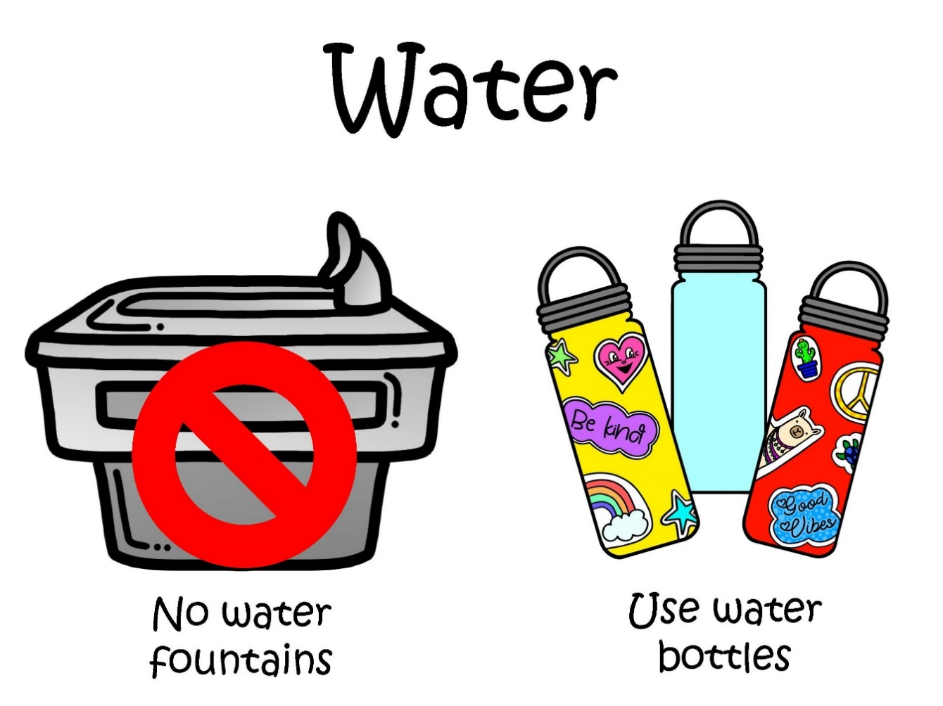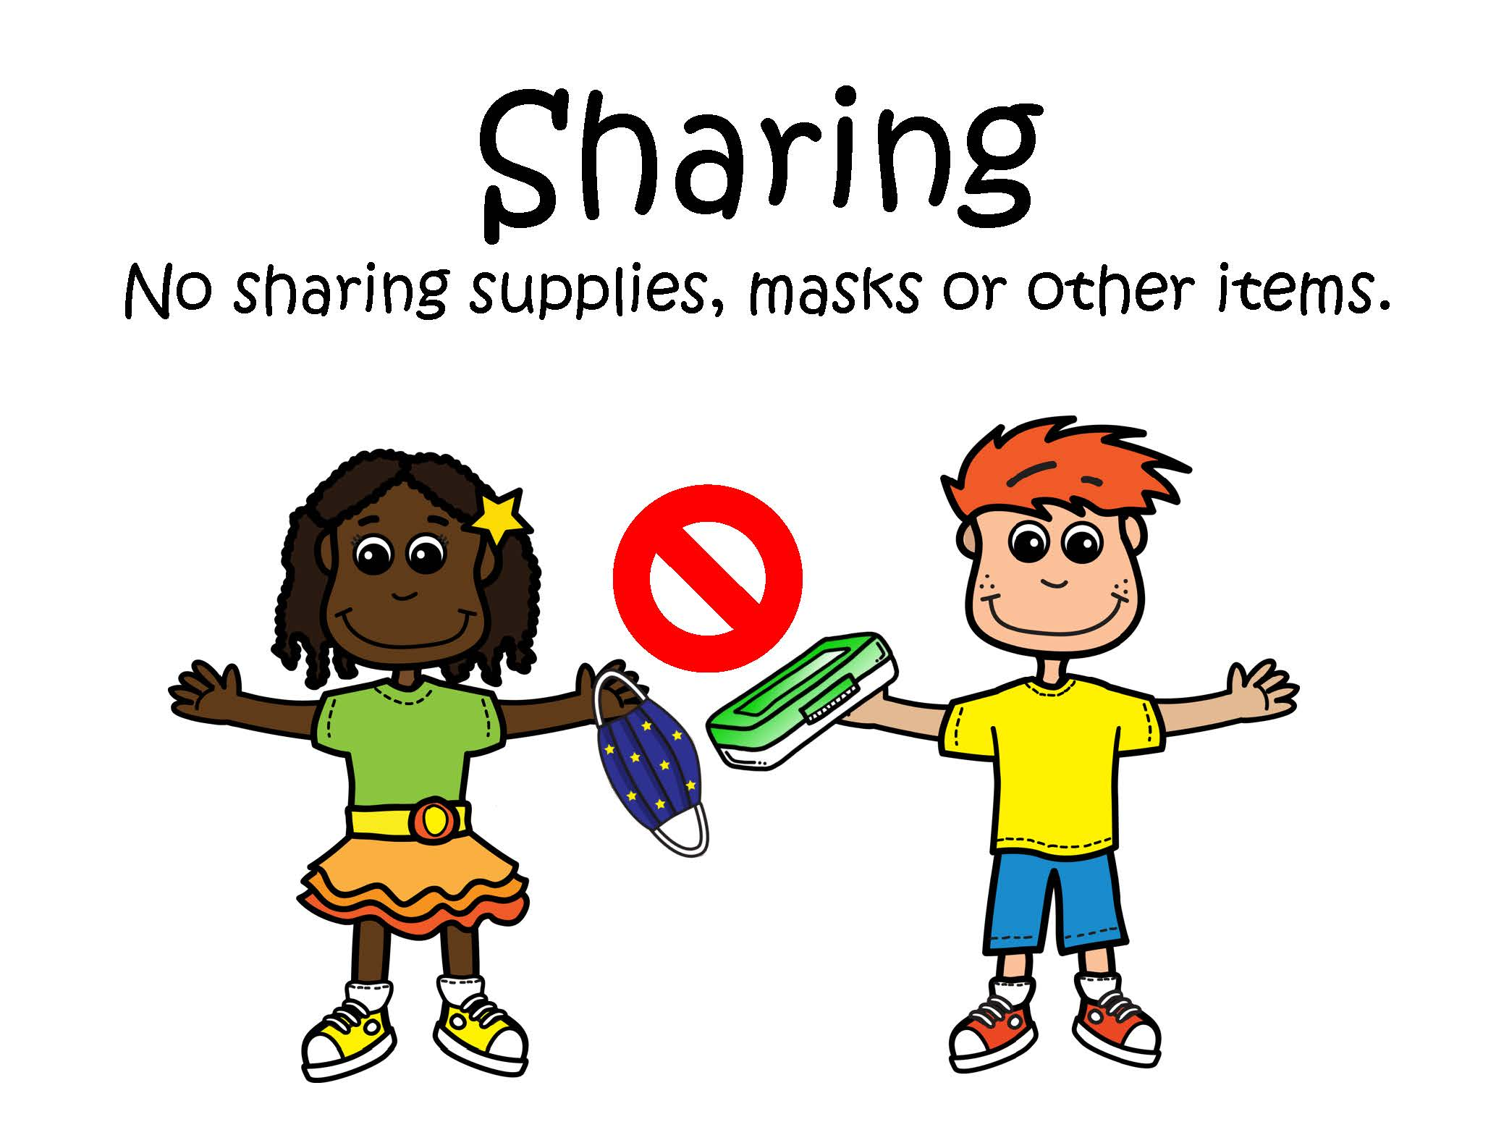

Health office visit

Highland Park Health Office Visit Request
Student Name: ________________________________________ Date: __________________________
Teacher: _________________________________________ I have tried: (please mark all that apply)
_____ Drink of Water_____ Rested Head ______ Bathroom Break
_____ Positive self-talk_____ 5 deep breaths______ Count back from 10
_____ Other (specify): _____________________________________________________________________________

Student main concern: ________________________________________________________ (please mark all that apply)

 | Primary Symptoms: |  | Secondary Symptoms:
 | Cough (not asthma related) |  | Headache
 | Shortness of breath (not asthma) |  | Muscle Pain
 | Breathing difficulty (not asthma) |  | Sore throat
 | Fever of 100.4 or higher |  | Congestion or runny nose
 | Chills |  | Nausea or Vomiting
 | Loss of Taste or smell |  | Diarrhea
 |  |  | Other:
 | Other Symptoms:
 | Rash
 | Stomach Pain

Covid-19 incident communication & reporting

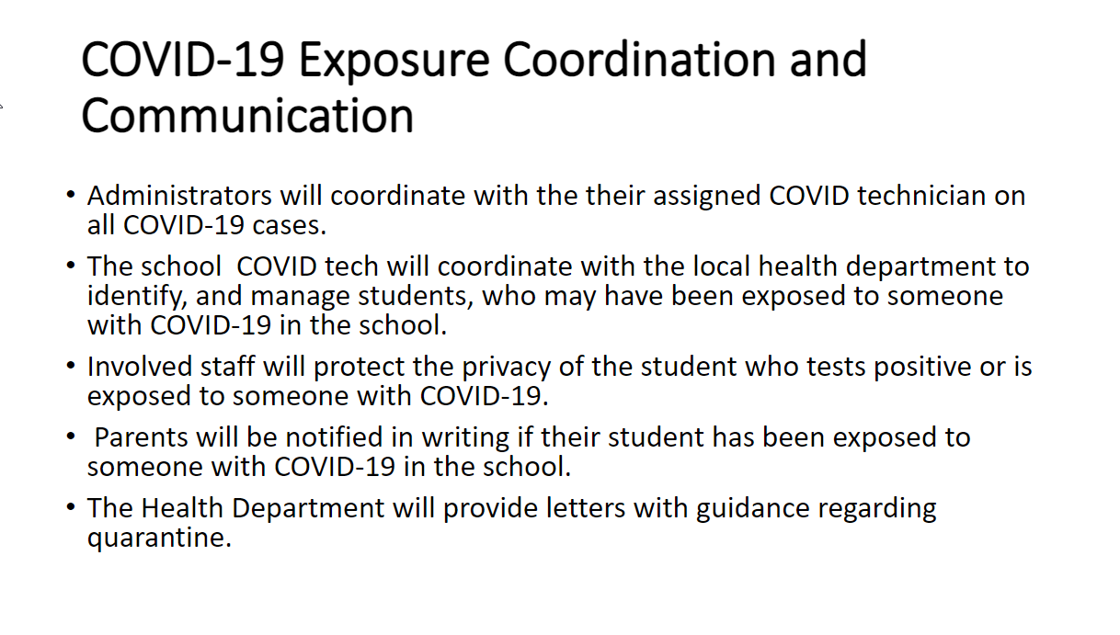

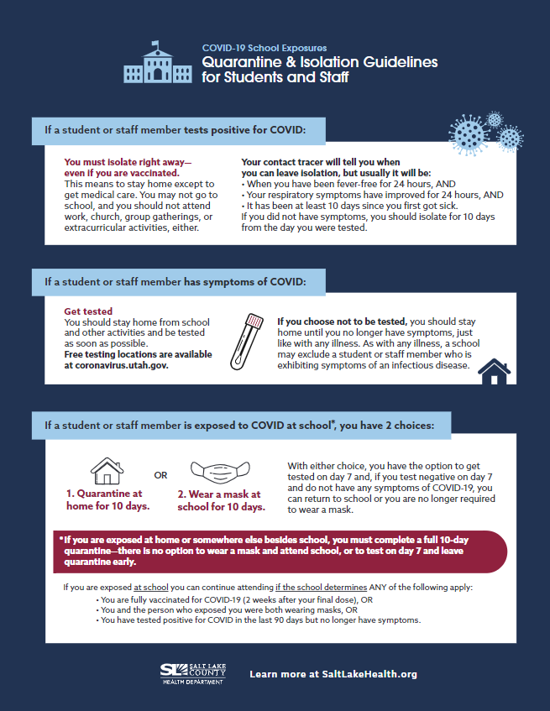

Checklist of COVID-19 exposures
